DAY 1

K . Nithin Sai

1 9 2 1 2 4 0 2 4

S o f t w a r e e n g I n e e r I n g

C S A 1 0 0 1

D R . G . M a r y V a l a n t I n a

Experiment no 1:

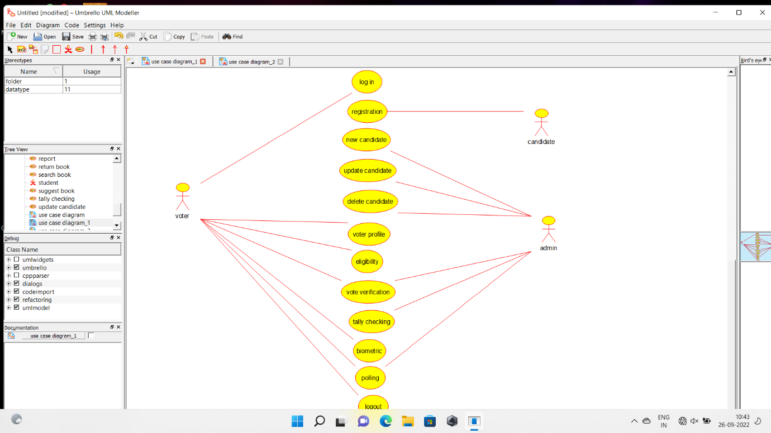

Experiment no 2

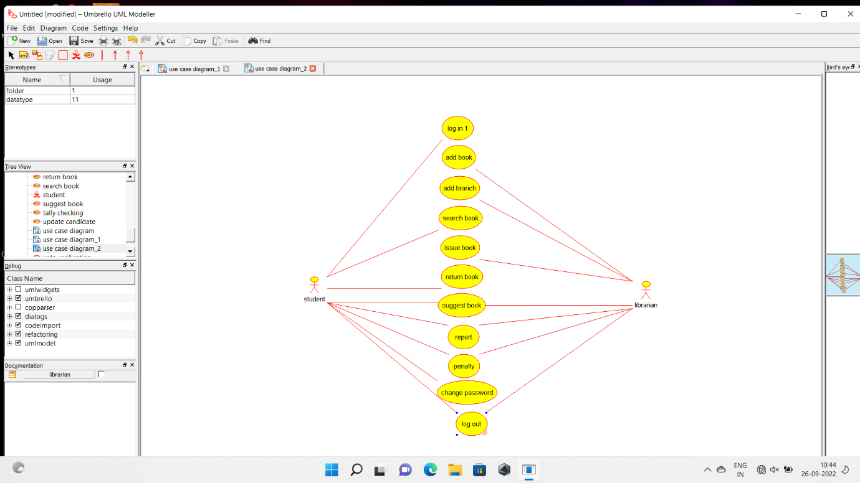

Experiment no 3

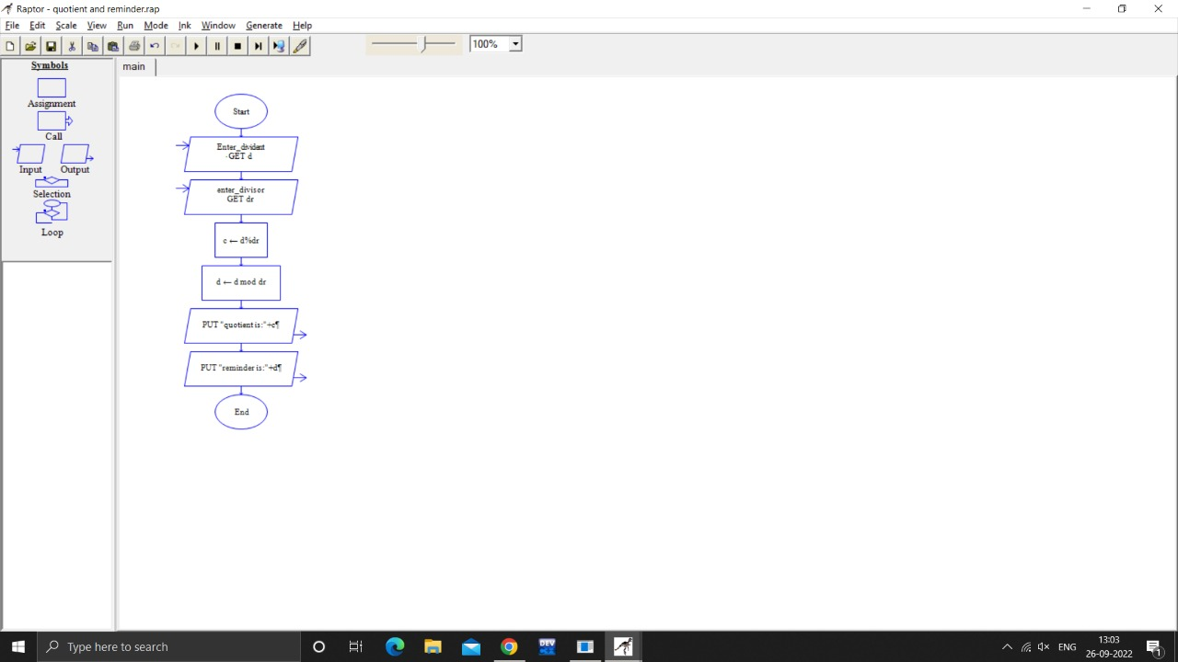

Experiment no 4

